**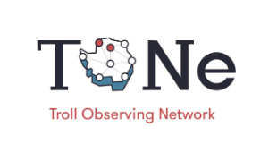                                                                 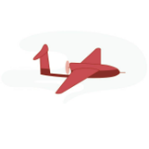**

# The Troll Observing Network (TONe) drone access call application form

See the full call on <https://npolar.no/tone/>

## Part A: PERSONAL INFORMATION

|  |  |
| --- | --- |
| **Project name** |  |
| **Project acronym** |  |
| **Project type** |  |
| **Name principal investigator (PI)** |  |
| **Email PI** |  |
| **Affiliation PI** |  |
| **Investigator and contact information for access request (if it differs from the PI)** |  |
| **Partner institutions (if any)** |  |
| **Name of collaborators at partner institution (if any)** |  |

Figur

## Part B: PROJECT DESCRIPTION

**Short description** Short summary of the proposed mission (max. 300 characters including spaces)

|  |
| --- |
|  |

**Project/program summary** Summary of the main project and the need for data to support this (max. 4000 characters including spacing).

|  |
| --- |
|  |

**Detailed data need description** Detailed description of type of data, geographical area to be covered, time period data should be collected, and other data and metadata requirements. The final route planning will be a dialogue between the drone operators and the scientists and will be developed at a later stage. Mapping tools are available from f.ex. Quantarctica. Details can be provided in an attachment.

|  |
| --- |
|  |

**Research Priorities Alignment**Description on how this project complement Norwegian research priorities or the TONe project at Troll (max. 300 characters including spaces).

|  |
| --- |
|  |

**Discipline** (Select all that apply)

 Atmosphere

Marine biology

Terrestrial biology

Cryosphere

Geology

Oceanography

Space Physics

 Technology and engineering

 Other

Figur

## Part C: MANDATORY ATTACHMENTS

1. **CV**  CV of the Principal Investigator (up to 2 pages)
2. **Data requirements and map/shapefile** A detailed description of data requirements and map of the area requested covered.

## Part D: AUTHORIZE

By ticking this box you confirm that your application is authorized by the head/research director of your institution.